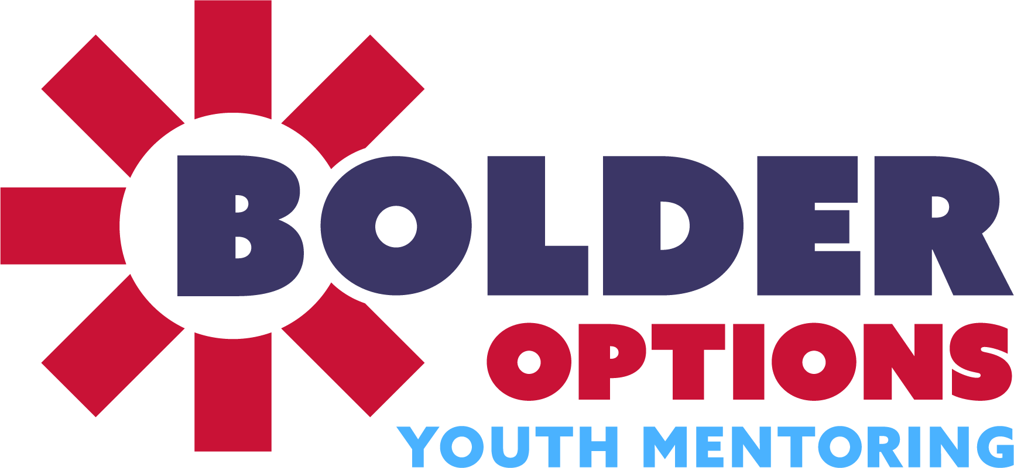

Youth Referral Form

***Youth Criteria:******1)*** *Ages 10-14;* ***2)*** *Will benefit from volunteer adult support;* ***3)*** *Want a mentor and are willing to be physically active;* ***4)*** *Reside in the Twin Cities metro area? Specify our service area?*

**Referral Date: ______ / ______ / ______**

**Youth Information**

Youth Name (First & Last):______________________________________________________________

Address:________________________________________________________________________________

City/State/Zip:__________________________________________________________________________

Primary Caregiver(s) Name:_____________________________________________________________

Caregiver Cell Phone:_________________________ Other Phone #:__________________________

Caregiver email:________________________________________________________________________

Caregiver’s Relationship to Youth:______________________________________________________

Is more than one parent involved?

Yes / No

Youth’s Gender Identity:________________

Youth’s Pronouns:______________________

Youth’s D.O.B.: _______ / _______ / ________

Youth Age at Referral: __________________

Youth Ethnicity (check all that apply):

* American Indian/Alaska Native
* Asian
* Black/African American
* Native Hawaiian/Pacific Islander
* White/Caucasian
* Hispanic/Latino
* Other Race

**Referring Agency Information**

Name of referring staff:______________________________________________________________

Agency:_______________________________ Position/Title:________________________________

Address:________________________________ City/State/Zip:______________________________

Phone:__________________________________ Email:_____________________________________

Agency Type:___________________________ Relationship to youth: ______________________

**Primary Enrollment Reason (only select one):**

| ▢ Academic Challenges | ▢ Living in High Risk Community |
| --- | --- |
| ▢ Children of Incarcerated Parents | ▢ Mental Health |
| ▢ Family Stress/Risk | ▢ Lack of Social Skills |
| ▢ Lack of Access to Social Engagement or Recreation | ▢ Other |

**Other Enrollment Reason(s):**

| ▢ Academic Challenges | ▢ Living in High Risk Community |
| --- | --- |
| ▢ Children of Incarcerated Parents | ▢ Mental Health |
| ▢ Family Stress/Risk | ▢ Lack of Social Skills |
| ▢ Lack of Access to Social Engagement or Recreation | ▢ Other |

**Protective Factors:**

| ▢ Family Involvement | ▢ Community Involvement |
| --- | --- |
| ▢ Academic Interest | ▢ Sense of Self-Efficacy |
| ▢ Strong Relational Skills | ▢ Non-academic Special Interest or Goals |
| ▢ Stable Housing & Basic Needs | ▢ Athletic or Creative interests |

**Target Populations:**

| ▢ Youth who have experienced victimization | ▢ Youth with disabilities |
| --- | --- |
| ▢ Youth who are underperforming in school | ▢ Youth in rural communities |
| ▢ Children of incarcerated parents | ▢ American Indian/Alaska Native youth |
| ▢ Youth who identify as LGBTQ+ | ▢ Black & Brown youth |
| ▢ Neuro-divergent youth | ▢ Youth in low income households |
| ▢ Youth who experience anxiety & depression | ▢ Children of immigrant parents |
| ▢ Youth who have been adopted or in foster care |  |

**COMMUNITY AGENCY INFORMATION**

What other relevant community agencies does this youth work with?

**PROGRAM CONSENT**

Please initial beside each program requirement.

_______ The family has been informed of this referral.

_______ The youth has been informed of this referral.

_______ The youth and family are aware that this is a one year program.

_______ The youth will meet with their mentor 2-4 hours each week.

_______ The youth is aware of the requirements to attend 12 Bolder Options events, and

setting and achieving 2 goals.

**PROGRAM CONSIDERATIONS**

In order to best match your youth with a mentor, please answer the following questions so that we may know a little bit more about them.

*I believe Bolder Options is a good fit for this youth because:*

*This youth’s interests and activities are:*

*This youth’s emotional and/or physical behaviors you should be aware of are:*

*These behaviors occur when/if:*

*This youth’s coping skills are:*

*How can our volunteer mentors and staff at Bolder Options support this young person when they’re experiencing emotional and/or physical behaviors?*

*The aspect(s) of Bolder Options this youth is excited about is(are):*

*The aspect(s) of Bolder Options this youth is wary about is(are):*

*This youth plans to support the match by:*

*This youth’s family plan to support the match by:*

*Best way to community with this youth and their family:*

*Other Comments:*

**Please mail or fax completed referral forms to:**

| **TWIN CITIES**  **2100 Stevens Ave S Minneapolis, MN 55404**  **Fax: (612) 234-4710**  **Email:** [**support@bolderoptions.org**](mailto:support@bolderoptions.org) | **ROCHESTER**  **2830 18th Ave NW, Rochester, MN 55901**  **Fax: (507) 216-6552**  **Email:** [**sarah.schaller@bolderoptions.org**](mailto:sarah.schaller@bolderoptions.org) |
| --- | --- |